**Thomas Jung**

**112757844**

**ECE 4973/5833: VLSI Digital System Design**

**Project 1: 2-Input NOR using Cadence**

1. **2 input NOR Gate**

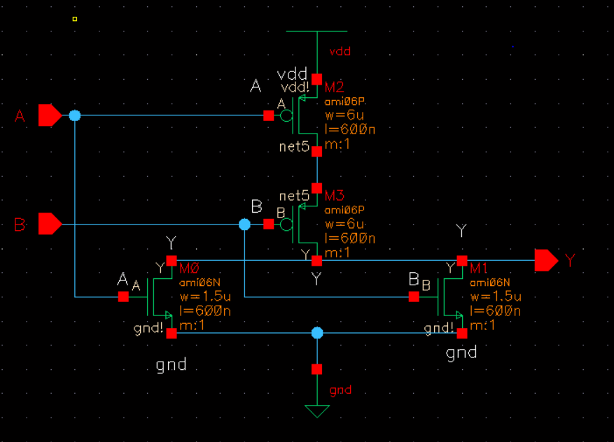

Above picture shows schematic of 2 input NOR gate made from 2 NMOS and 2 PMOS connected as the CMOS logic. The NMOS transistors have unity width of 1.5uM while the PMOS has double the value of the unity NMOS but another double value since it’s in series, resulting in 6uM. Power supply of Vdd and gnd were also used in the schematic.

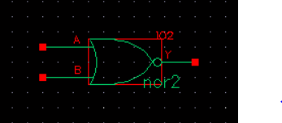

Above picture shows a simplified version of 2NOR logic gate made as a symbol in the Cad library.

1. **Transfer Functions of 2 NOR gate:**

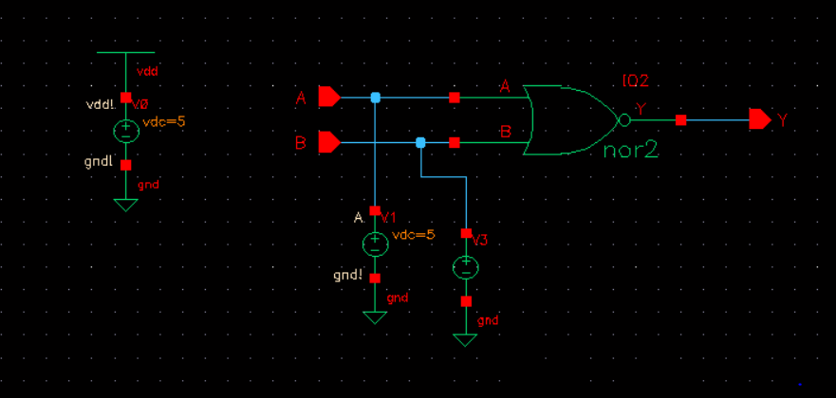

In order to operate DC transfer functions, more dedicated design of the 2 input NOR gate with power supplies and inputs and outputs are drawn above. A 5V DC and 0V DC logic level is simulated using a voltage source with sweep of 0 to 5V.

1. **DC Transfer Function for Input A**

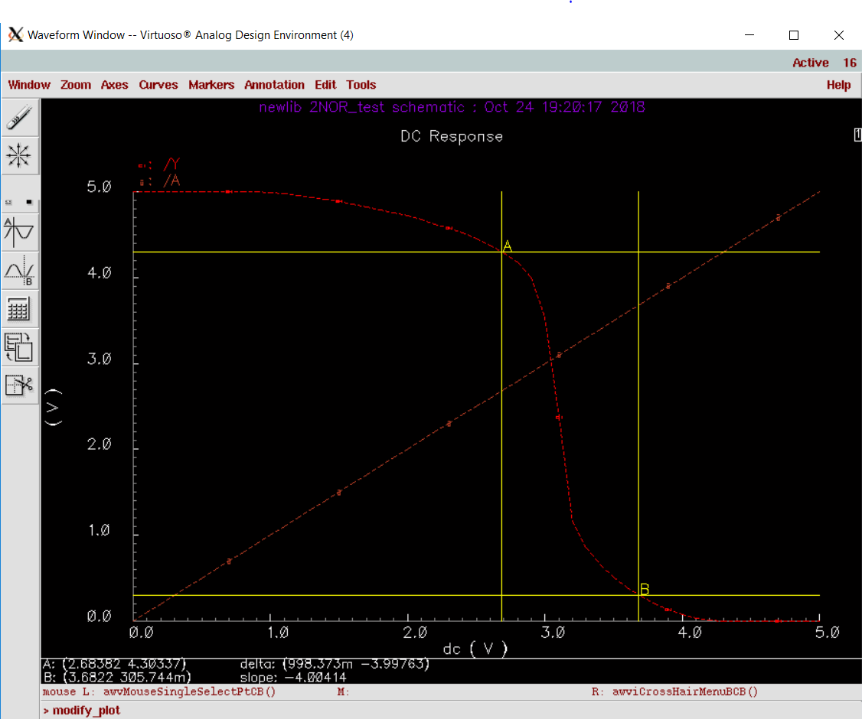

|  |  |
| --- | --- |
| Truth table for 2NOR | |
| A | B | | Y |
| 0 | 0 | | 1 |
| 0 | 1 | | 0 |
| 1 | 0 | | 0 |
| 1 | 1 | | 0 |

As shown above in the truth able, the graph above shows logic high for when both inputs are 0 and when either is 0. The graphs shows logic high for when A is 1 and B is 0 When both are 1, it’s logic low.

The unity gain for input A and B are marked to calculate the high and low noise margins.

NMH = 4.30337 – 3.6822 = 0.62117V

NHL = 2.68382 – .305744 = 2.378076V

Low Noise Margin are 3 times higher than High Noise Margin for NOR2.

1. **DC Transfer Function for Input B**

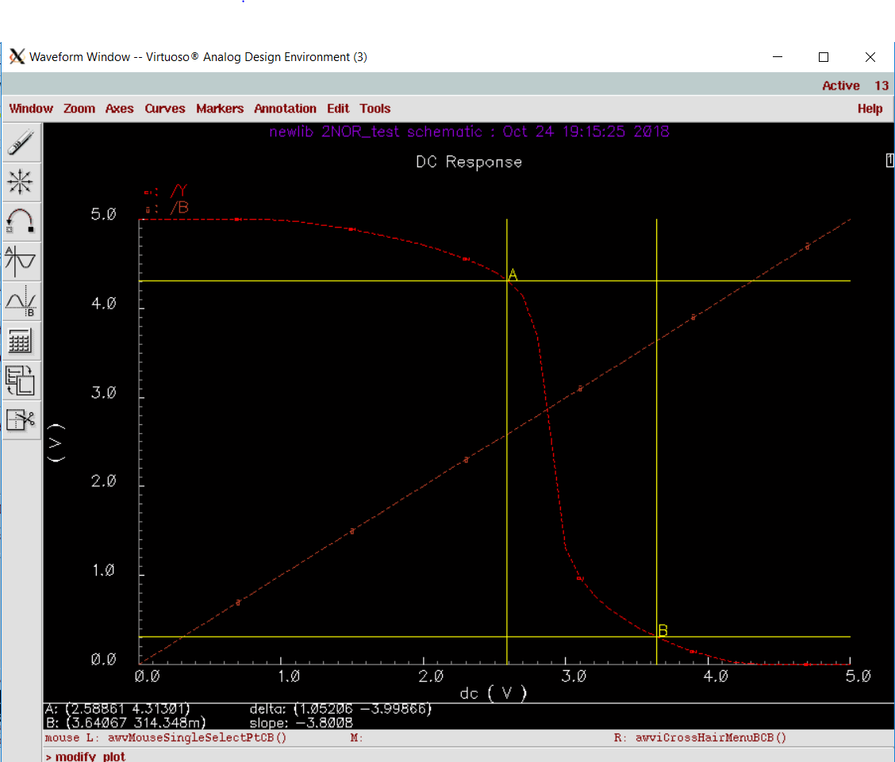

The unity gain for input A and B are marked to calculate the high and low noise margins.

NMH = 4.31301 – 3.64067 = 0.67234 V

NHL = 2.58861 – .314348 = 2.274262 V

Low Noise Margin are 3 times higher than High Noise Margin for NOR2. Very similar to input A but a bit higher on high margin and a bit less in low margin.

1. **Transient Response**

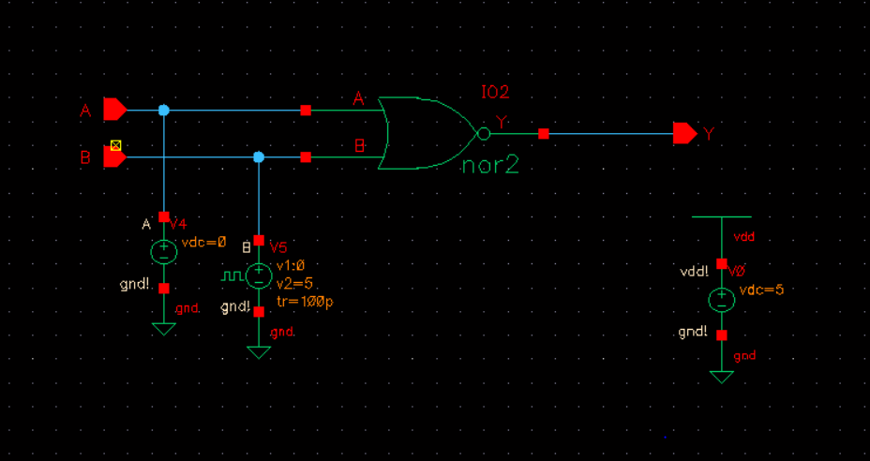

To operate the transient response of 2NOR simulation, one of the voltage supplier of the two inputs has been changed to pulsed source with rise and fall times of 100ps, a pulse width of 1ns, and a period of 2ns, the input pulse varying from 0 V to 5V. This was simulated in 10ns for both inputs of A and B.

1. **Transient Response of Input A**

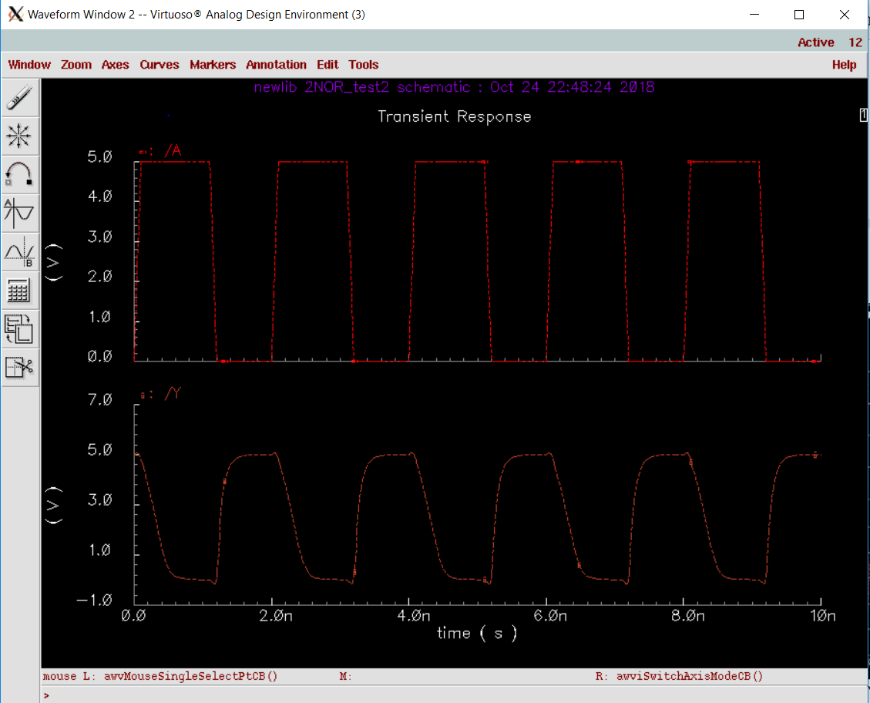The above graph shows transient behavior of input A and output Y. The wavelengths have been separated. You can see inverse relationship between input A and output Y. For example, when input A is rising, output is falling, and vice versa.

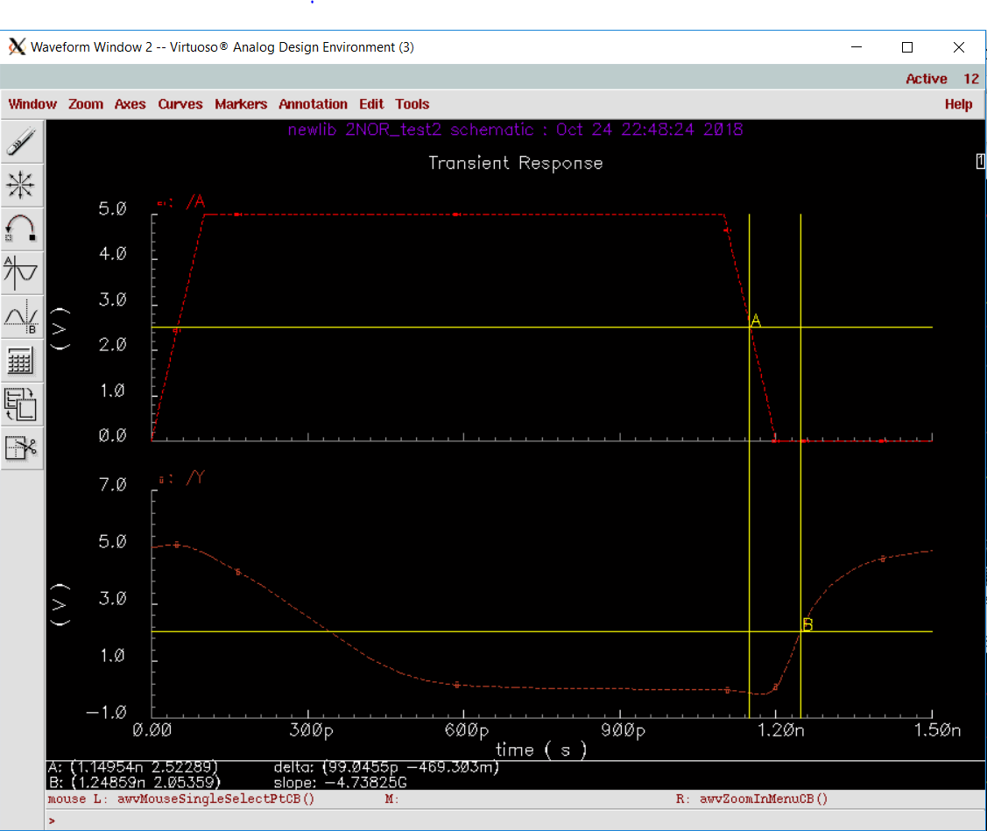

The above image shows zoomed-in image of the transient behavior of input A and output Y for rising edge. The markers are place at 2.5V, which is the ideal marginal value of Vdd/2. The delay measured was 99.0455ps.

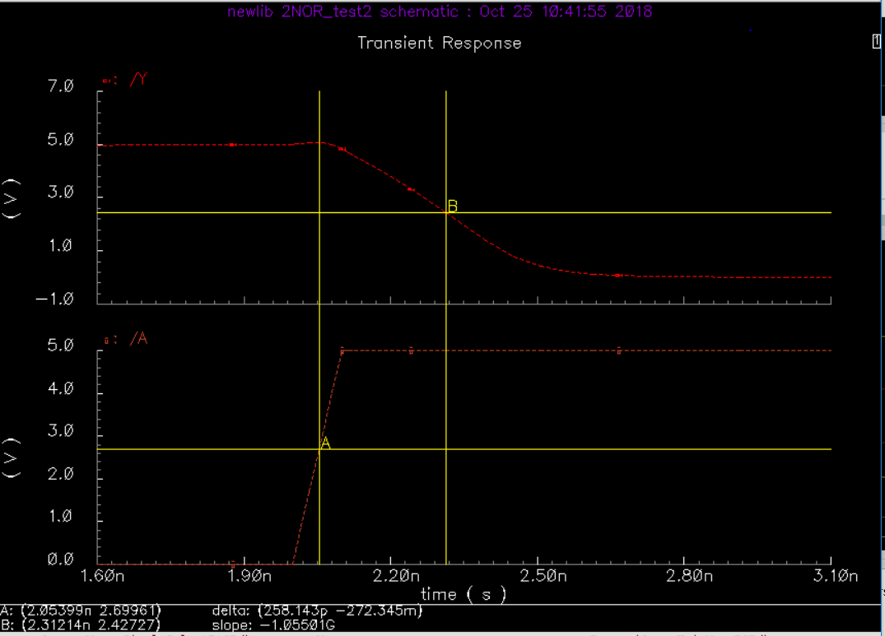

The above image shows zoomed-in image of the transient behavior of input A and output Y for falling edge. The markers are placed close to 2.5V, which is the ideal marginal value of Vdd/2. The delay measured was 258.143ps.

1. **Transient Response of Input B**

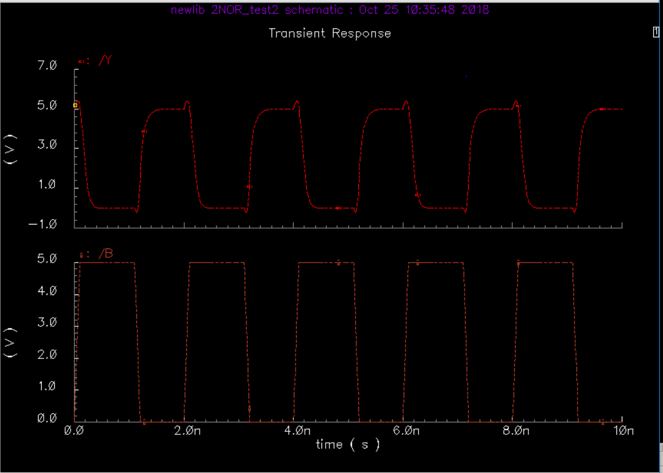

Separated wavelength between input and output of transient response.

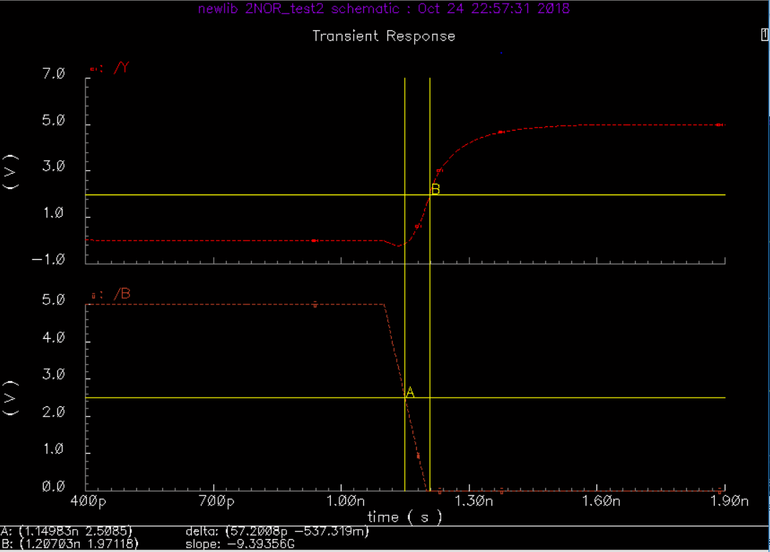

The above image shows zoomed-in image of the transient behavior of input B and output Y. The markers are place close to 2.5V, which is the ideal marginal value of Vdd/2. The delay measured was 57.2008 ps.

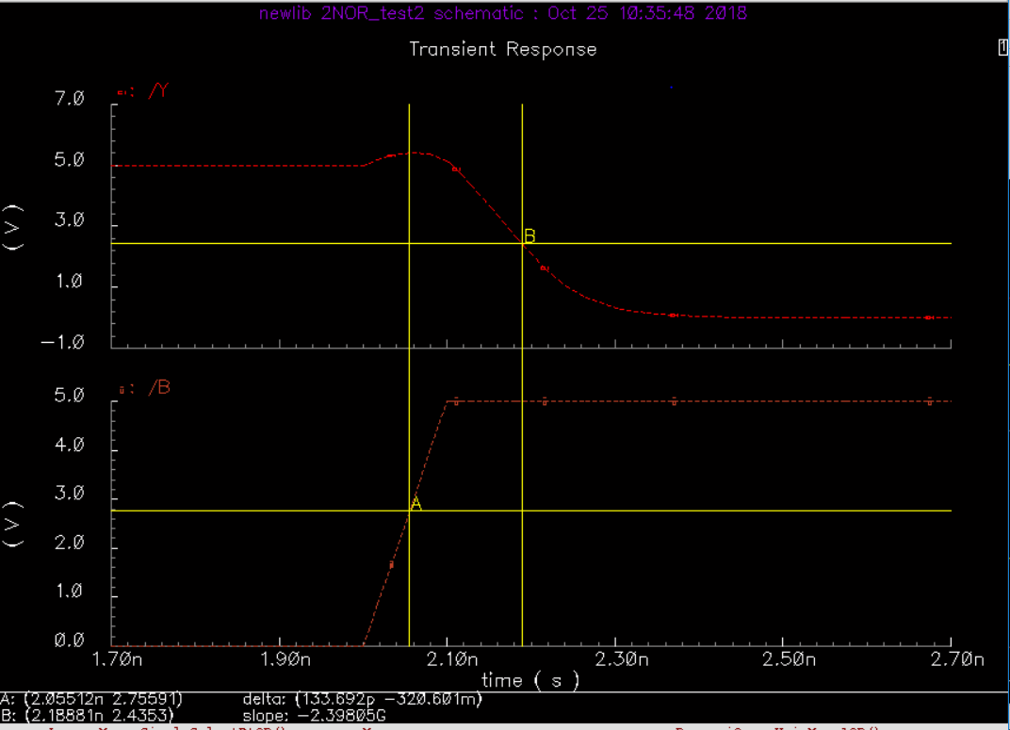

The above image shows zoomed-in image of the transient behavior of input B and output Y. The markers are place close to 2.5V, which is the ideal marginal value of Vdd/2. The delay measured was 133.692 ps.